PROJECT PLAN
Department: | EC | Semester: | 6th | Academic Year: |  | 2026– 27
A. Proposed Title of the Project:
Universal Asynchronous Receiver and Transmitter (UART)
B. Name(s) of guide(s): Prof. / Dr. / Mr. / Ms.
C. Name of Team Members (Strictly not more than four students in a batch):
USN | Name
4VP23EC050 | Mr. THIYANAND M | Team Leader
4VP23EC005 | Ms. CHAITHANYA | Team Member
4VP23EC029 | Ms. PREETHA S M | Team Member
4VP23EC010 | Ms. FATHIMATH ANEESHA | Team Member

D. Date of commencement of project:
E. Probable date of completion of the project:
F. If this project is an improvement / extension of an earlier project, please give the title of earlierproject and the year in which it was carried out. Specify the improvements / modifications clearly:
Not Applicable
G. Objectives of the project highlighting its importance (not more than half a page):
- To design and implement a Universal Asynchronous Receiver and Transmitter (UART) using basic digital electronic components on a breadboard.
- To understand the concept of asynchronous serial communication without using a common clock between transmitter and receiver.
- To study the working of UART transmitter and receiver including start bit, data bits, and stop bit.
- To analyse baud rate generation and synchronization in serial communication.
- To bridge theoretical communication concepts with practical hardware implementation using UART
H. Block diagram and Methodology (Not more than a page):

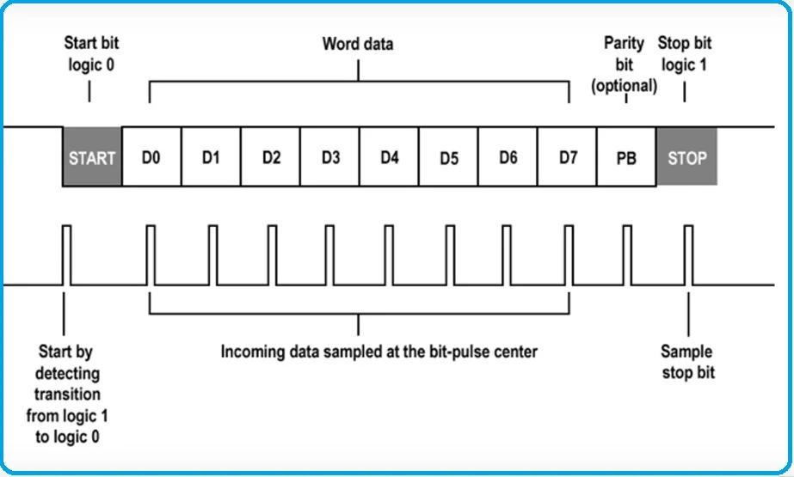

The device operates in the following sequence:
- Power Supply Setup
A regulated 5V power supply is designed and tested to ensure stable operation of all ICs used in the UART circuit.
- Clock / Baud Rate Generation
A clock or baud rate generator circuit is implemented to control the speed of serial data transmission and reception.
- UART Transmitter Design
The transmitter circuit converts parallel data into serial form by adding start and stop bits using shift registers and control logic.
- UART Receiver Design
The receiver circuit detects the start bit, samples incoming serial data at the selected baud rate, and converts it back into parallel data.
- Data Registers and Buffers
Registers are used to temporarily store transmitted and received data during communication.
- Control Logic Implementation
Control logic is designed to manage data loading, shifting, and synchronization between the transmitter and receiver.
- Simulation and Verification
The UART design can be simulated and verified using tools such as Proteus or ModelSim before or alongside breadboard implementation.
- Testing and Output Verification
The complete UART system is tested on a breadboard and verified for correct data transmission and reception using LEDs or interfacing devices.

I. Expected Outcome of the project:
- Successful design and implementation of a functional UART system.
- Correct transmission and reception of serial data using asynchronous communication.
- Proper generation and detection of start, data, and stop bits.
- Reliable operation of UART at the selected baud rate.
- Improved practical understanding of serial communication used in embedded systems.
J. Application of the project:
- Used for serial communication in microcontroller-based systems.
- Widely applied in embedded and IoT systems for data exchange.
- Used in communication between computers and peripheral devices.
- Serves as an educational model to understand UART protocol and serial communication.
- Useful for digital electronics and communication laboratory experiments.
K. Does the project proposed is relevant to any of the Industry or Institution in and around your area (Yes / No): |  |  |  |  | No
L. If yes, please provide details of the industry / institution and contact details:
M. Budget:
Materials Cost: 5500/-  Labour Charges:  Any other cost: |  |  |  |  | Source of Funds:  Self / Industry / Others
N. Expected Completion Time:
Expected Time for Major Activities |  |  |  |  | Schedule
Synopsis (Project Plan) submission to the Department
Presentation of synopsis
Last date for re-submission (if applicable) & review
Submission of Reports
Internal Viva and/or Project Exhibition
O. Authors:
Student(s) / Author(s) |  |  |  |  | Signature with date
1.THIYANAND M
2.CHAITHANYA
3.PREETHA S M
4.FATHIMATH ANEESHA
Checked By: |  |  |  |  | Signature with date:
P. Guidance:
Guide (s) allotted: |  |  |  |  | Signature (s) with date
1. Guide: Prof. / Dr. / Mr. / Ms.
2. Co-Guide (if any): Prof. / Dr. / Mr. / Ms.

